HOW TO PARAPHRASE

How would you paraphrase the underlined sentences taken from page 407 of your textbook?
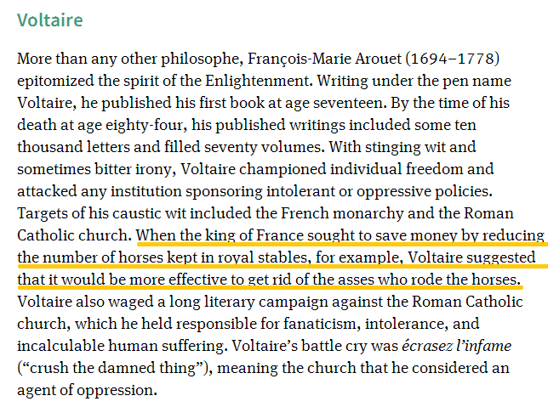
Reference
Bentley, J., Ziegler, H., Streets-Salter, H. (2010). Traditions & encounters: A brief global history Vol. II. New York, NY: McGraw Hill.
Works Cited
Bentley, Jerry, Herbert Ziegler, and Heather Streets-Salter. Traditions & Encounters: A Brief Global History Vol. II. New York, NY: McGraw Hill, 2010. Print.

Paraphrasing: Which sample is correct?
Sample Paraphrase 1  When the King of France attempted to reduced his spending by reducing the size of his stable, Voltaire suggested that it would be more effective to get rid of the asses who rode the horses. | Sample Paraphrase 2  When the King of France attempted to save money by downsizing the number of horses kept in royal stables, Voltaire suggested that it would be more effective to get rid of the asses who rode the horses.
Sample Paraphrase 3  Voltaire suggested that it would be more effective to get rid of the asses who rode the horses when the King of France sought to save money by reducing the number of horses kept in royal stables. | Sample Paraphrase 4  Voltaire mocked the King of Franceʻs attempt to reduce spending by drawing a parallel between reducing the number of royal horses and reducing the number of incompetent court officials.

HOW TO QUOTE

How would you quote the underlined sentences taken from page 407 of your textbook?

Reference
Bentley, J., Ziegler, H., Streets-Salter, H. (2010). Traditions & encounters: A brief global history Vol. II. New York, NY: McGraw Hill.
Works Cited
Bentley, Jerry, Herbert Ziegler, and Heather Streets-Salter. Traditions & Encounters: A Brief Global History Vol. II. New York, NY: McGraw Hill, 2010. Print.

Quoting: Which sample is correct?
Sample Quotation 1  “Voltaire suggested that it would be more effective to get rid of the asses who rode the horses.” (Bentley, Streets-Salter, and Ziegler, 407). | Sample Quotation 2  “Voltaire suggested that it would be more effective to get rid of the asses who rode the horses.” (Bentley 407).
Sample Quotation 3  According to Bentley, Ziegler, & Streets-Salter (2010), “Voltaire suggested the King of France should get rid of the asses who rode the horses” (p. 407). | Sample Quotation 4  According to Bentley, Ziegler, & Streets-Salter, “Voltaire suggested that it would be more effective to get rid of the asses who rode the horses” (2010).
Sample Quotation 5  According to Bentley, Streets-Salter, & Ziegler, “Voltaire suggested that it would be more effective to get rid of the asses who rode the horses” (p. 407). | Sample Quotation 6  According to Bentley, Ziegler, & Streets-Salter, “Voltaire suggested that it would be more effective to get rid of the asses who rode the horses” (407).

